CVV PRESS RELEASE

Contact: Thalía Muñoz-Malavé
Event Coordinator, Capay Valley Vision
munozthalia17@gmail.com
724.771.1651

Matt Trask
President, Capay Valley Vision
m_trask@yahoo.com
916.804.7271

CAPAY VALLEY VISION AWARDS LOCAL FIRE DEPARTMENTS,
HOSTS ANNUAL TASTE OF CAPAY DINNER

The non-profit raised $12k for volunteer fire departments in the Capay Valley

Capay, CA- Founded in 2001, Capay Valley Vision was created to support ongoing communications within the diverse Capay Valley. The organization endeavors to preserve the Valley's rural character, agriculture, history and natural environment while amplifying and promoting a local vital economy.

Taste of Capay is an annual farm-to-table dinner organized by CVV to raise funds for community efforts while supporting businesses and products grown in the Capay Valley. In October of 2022, the 21st Annual Taste of Capay fund raised $12k for the Capay, Esparto, and Madison volunteer fire departments. These fire districts are essential resources for the protection and survival of the Capay Valley community. Capay Valley Vision would like to thank everyone who attended, sponsored, or volunteered to help make this longstanding event possible.

Mark your calendars because the 22nd Annual Taste of Capay will be held at Taber Ranch Vineyards on Sunday, November 5, 2023. This year's event will benefit the Capay Valley Regeneration Group for funding of local restoration project, and Capay Valley Grown, a partnership of local farmers and ranchers formed to promote agriculture in the Valley.

For more information, please visit: http://www.capayvalleyvision.net
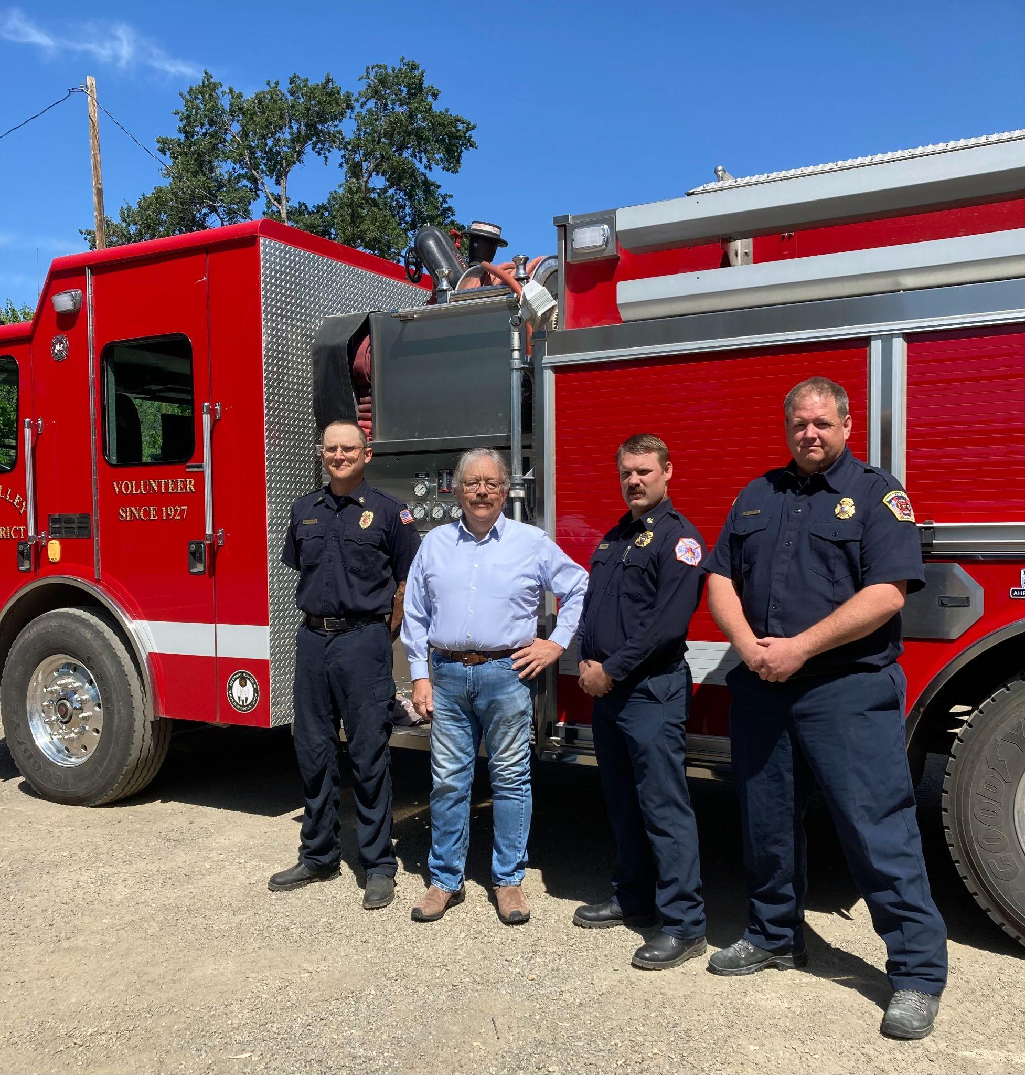
Pictured: Capay Valley Fire Protection District Chief: Jesse Capitanio, Capay Valley Vision President: Matt Trask, Esparto Fire Protection District Chief: Curtis Lawrence, Madison Fire Protection District Chief: Paul Green

